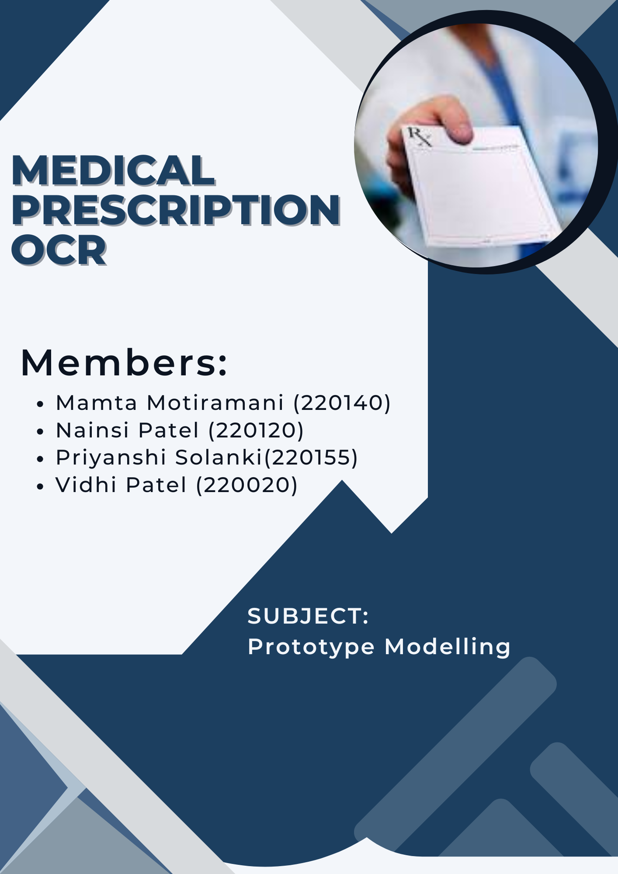

**CERTIFICATE**

This is to certify that **Ms. Vidhi Patel** having **Enrollment No: 220020** has completed Project Report for the subject of Prototype Modelling having title Medical Prescription OCR, in a group consisting of 4 people under the guidance of the Faculty Guide Rucha Patel.

Signature of the supervisor

Ms Rucha Patel

**CERTIFICATE**

This is to certify that **Ms. Nainsiben Patel** having **Enrollment No: 220120** has completed Project Report for the subject of Prototype Modelling having title Medical Prescription OCR, in a group consisting of 4 people under the guidance of the Faculty Guide Rucha Patel.

Signature of the supervisor

Ms Rucha Patel

**CERTIFICATE**

This is to certify that **Ms. Mamta Motiramani** having **Enrollment No: 220140** has completed Project Report for the subject of Prototype Modelling having title Medical Prescription OCR, in a group consisting of 4 people under the guidance of the Faculty Guide Rucha Patel.

Signature of the supervisor

Ms Rucha Patel

**CERTIFICATE**

This is to certify that **Ms. Priyanshi Solanki** having **Enrollment No: 220155** has completed Project Report for the subject of Prototype Modelling having title Medical Prescription OCR, in a group consisting of 4 people under the guidance of the Faculty Guide Rucha Patel.

Signature of the supervisor

Ms Rucha Patel

**ACKNOWLEDGEMENT**

Before we get into the thick of things, we would like to add a few words of appreciation for the people who have been part of this project right from the beginning. We are truly thankful to everyone who has helped us in this journey, directly or indirectly.

We would like to express our sincere gratitude to our project guide, **Prof. Rucha Patel**, for her constant support, encouragement, and guidance throughout the development of our project, **Medical Prescription OCR**. Her insights and suggestions have been incredibly valuable and have helped us improve at every stage. Her mentorship provided us with the direction and motivation to bring our ideas to life.

We are also thankful to our department and everyone who supported us during the course of this project.

Sincere Thanks.

**ABSTRACT**

Handwritten medical prescriptions remain a common and essential component of healthcare communication, especially in developing nations where digital health infrastructure is still evolving. However, the illegibility of handwritten prescriptions poses a serious risk to patient safety, often leading to medication errors, incorrect dosages, and adverse drug reactions. To address this critical problem, our project—Medical Prescription OCR—proposes a prototype system that leverages modern computer vision techniques to digitize handwritten prescriptions, extract textual content, and display it in a clear, readable format via a static web interface.

The system combines classical image preprocessing methods with deep learning-based handwriting recognition, specifically using a Convolutional Neural Network (CNN) model trained on the EMNIST dataset. A frontend web platform has been developed to simulate OCR processing, allowing users to upload an image, trigger text extraction (via dummy JavaScript logic), and receive a neatly formatted digital version of the prescription. The system includes a sign-in/sign-up feature, a prescription history page, and a responsive, mobile-friendly design—all contributing to a smooth user experience.

While the current version of the project simulates backend OCR output, it is designed to be easily extendable for real-time model integration using TensorFlow Lite or ONNX. This project not only serves as an academic endeavor but also lays the groundwork for real-world implementation in pharmacies, clinics, and hospitals, ultimately contributing to safer and more efficient healthcare delivery.

**Table of Contents**

**Chapter Name**

Certificate

Acknowledgement

Abstract

Index

### **Chapter 1: Introduction**

1.1 Background and Motivation  
1.2 Problem Statement  
1.3 Objectives of the Study  
1.4 Scope of the Study  
1.5 Significance of the Project  
1.6 Organization of the Report

### **Chapter 2: Review of Related Literature**

2.1 Introduction to OCR Systems  
2.2 Classical OCR vs Handwriting Recognition  
2.3 Deep Learning Techniques for Handwriting Recognition  
2.4 EMNIST Dataset and its Relevance  
2.5 Existing Applications in Healthcare  
2.6 Limitations in Current Research  
2.7 Summary of Literature Review

### **Chapter 3: Methodology and Procedures**

3.1 System Overview  
3.2 Technology Stack Used  
3.3 Dataset Description  
3.4 Architecture of the OCR Pipeline  
  3.4.1 Image Loading and Resizing  
  3.4.2 Grayscale Conversion  
  3.4.3 Preprocessing and Noise Reduction  
  3.4.4 Thresholding and Binarization  
  3.4.5 Contour Detection and Character Segmentation  
  3.4.6 CNN-Based Character Recognition  
  3.4.7 Word Reconstruction and Post-processing  
3.5 CNN Model Architecture  
3.6 Training and Validation  
3.7 Limitations in the Method  
3.8 Summary

### **Chapter 4: Analysis and Interpretation of Features**

4.1 Description of Website Features  
  4.1.1 Home Page  
  4.1.2 How It Works Page  
  4.1.3 About Page  
  4.1.4 Contact Page  
4.2 Image Upload Interface  
4.3 Simulated OCR Output Display  
4.4 Sign In / Sign Up Flow  
4.5 User History Management System  
4.6 Frontend JavaScript Logic for OCR Simulation  
4.7 Mobile Responsiveness and UI Testing  
4.8 Visual Demonstrations (Screenshots)  
4.9 Accessibility & Usability Testing

4.10 Dataset Visualization  
4.11 Summary

### **Chapter 5: Major Findings of the Study**

5.1 Observations from Pipeline Output  
5.2 Accuracy Results from the CNN Model  
5.3 Comparison with Existing OCR Tools  
5.4 User Interface Feedback  
5.5 Summary of Results

### **Chapter 6: Results and Insights**

6.1 Practical Applications  
6.2 Benefits for Doctors, Patients, and Pharmacies  
6.3 Integration Possibilities with Health Management Systems  
6.4 Challenges Faced During Implementation  
6.5 Key Insights Gained

### **Chapter 7: Conclusion and Future Scope**

7.1 Conclusion  
7.2 Scope for Future Work  
7.3 Suggestions for Real-World Deployment  
7.4 Final Thoughts

### **References**

### **Appendices** Appendix A– CNN Model Summary Appendix B– Prototype PPT Overview

### 

### 

### 

### 

### 

# 

# 

# **Chapter 1 Introduction**

## 

## **1.1 Background and Motivation**

In the realm of healthcare, the prescription process is one of the most fundamental forms of communication between medical practitioners and patients. A prescription acts as a documented instruction for medication, treatment regimens, and other therapeutic guidance. Despite the global advancements in digital healthcare systems, handwritten prescriptions are still widely prevalent, especially in developing countries like India. However, this seemingly routine practice is not without its drawbacks. The biggest and most pressing issue is the **illegibility** of handwritten prescriptions—a problem often humorously attributed to “doctor’s handwriting,” yet one that has serious and sometimes fatal implications.

Illegible prescriptions can lead to numerous challenges. Pharmacists may misinterpret the name of a drug or dosage information. Patients may struggle to understand instructions, and in extreme cases, medication errors can result in severe health complications or death. Studies conducted by medical safety boards have shown that **a significant percentage of medical errors** stem from misread prescriptions. As a result, there is an urgent need to transform the way prescriptions are handled and interpreted.

The rapid growth of **artificial intelligence (AI)**, particularly **computer vision** and **deep learning**, offers promising solutions to this problem. **Optical Character Recognition (OCR)** technology, originally developed to recognize printed text, has evolved to include sophisticated models capable of interpreting cursive and handwritten characters. By applying these technologies, it is now possible to design systems that can automatically read, interpret, and convert handwritten prescriptions into structured, machine-readable formats.

Moreover, the advent of **machine learning frameworks** such as TensorFlow and PyTorch, and the availability of **handwriting-specific datasets** like EMNIST, have made it feasible to train models that mimic human reading capabilities. These tools, when integrated with frontend technologies like JavaScript, HTML5, and responsive design frameworks, can be used to build seamless, user-friendly systems that bring these AI capabilities directly to end users.

This project, titled **"Medical Prescription OCR,"** is motivated by the need to eliminate ambiguity from medical prescriptions and to digitize the healthcare communication pipeline. The goal is to enable patients, pharmacists, and healthcare providers to interact with a system that accepts images of prescriptions and provides a **clean, accurate, and legible digital version** of the handwritten content. By doing so, we aim to reduce medication errors, improve accessibility, and contribute toward the larger goal of smart, digitized healthcare.

In addition to its practical healthcare benefits, this project serves as a platform for academic exploration into OCR, deep learning, and frontend simulation of AI tasks. It combines multiple domains—image processing, CNN-based classification, user interface design, and information management—into a single, cohesive prototype that addresses a real-world problem with a technology-driven approach.

**1.2 Problem Statement**

The healthcare industry is built on the precision and accuracy of information. One of the most common and crucial forms of this information is the **medical prescription**, a document that translates a doctor’s diagnosis into actionable treatment for the patient. While prescriptions are traditionally considered simple and routine, a major flaw persists — **the illegibility of handwritten prescriptions**, especially those written in haste or by practitioners with stylized handwriting. This issue, long considered a running joke, has now been identified by global health agencies as a **serious medical risk** that can lead to dangerous consequences.

In developing countries such as India, a vast majority of prescriptions are still handwritten on paper slips. Despite the availability of digital alternatives, doctors continue to use handwritten formats due to habit, convenience, or lack of access to digital infrastructure. Pharmacists, patients, and caregivers are left to decipher these often poorly written notes, which may contain life-altering information. The absence of a standardized format, variations in handwriting styles, abbreviations, and sometimes even language inconsistencies further compound the difficulty of interpretation.

Misinterpretation of a handwritten prescription can lead to a range of consequences — from **dispensing the wrong medicine**, to **administering incorrect dosages**, or even **missing critical warnings or drug interactions**. The lack of a readable and digitized copy of a prescription also prevents long-term storage and retrieval, making it difficult for patients to maintain accurate medical records. This affects not only patient safety but also the efficiency of medical institutions and pharmacies.

Traditional OCR systems like **Tesseract OCR** perform well with printed or typed text but fail dramatically when applied to cursive handwriting or complex documents like prescriptions. The failure stems from their inability to segment and recognize characters when spacing is inconsistent, or when the script involves stylized strokes, abbreviations, and medical jargon. Moreover, current generic OCR solutions are not context-aware—they do not understand the structure or vocabulary typical of medical prescriptions, making their output less reliable in healthcare contexts.

The problem is not just technical but systemic. There is **no easily accessible tool** for the average user (patient, pharmacist, or junior healthcare worker) to simply scan or upload a handwritten prescription and instantly get a clear, digital representation of the text. Most advanced OCR tools are either too expensive, require backend infrastructure, or are not specialized for the medical domain.

Given the rapid advances in **machine learning, deep learning, and real-time image processing**, the opportunity now exists to bridge this gap. The challenge lies in creating a prototype system that is lightweight, easy to use, works in resource-constrained environments, and provides **a reliable simulation of handwritten prescription recognition**. This system must be accurate enough to extract meaningful information, yet intuitive enough to be used by non-technical users.

Thus, the problem we seek to solve is clear:

**"How can we create an intelligent, user-friendly tool that can extract text from handwritten medical prescriptions and present it in a clean, readable format using modern OCR and machine learning techniques?"**

This project attempts to address this problem by developing a static website prototype that simulates the functionality of such a tool. The solution combines image preprocessing techniques, CNN-based handwriting recognition, and a responsive web interface to demonstrate the feasibility of building an effective and scalable Medical Prescription OCR system.

## **1.3 Objectives of the Study**

The primary aim of this project is to address the long-standing issue of illegible medical prescriptions by developing a prototype that simulates the digitization and interpretation of handwritten prescription text. In the healthcare ecosystem, accuracy, clarity, and accessibility of information are paramount. Therefore, this project envisions a solution that empowers users—patients, pharmacists, and healthcare workers—with a tool that can instantly convert handwritten prescriptions into clean, readable digital text using OCR-based techniques.

In achieving this aim, the following **specific objectives** have been formulated:

### **1. To develop a clean, user-friendly static website interface**

One of the core goals is to design and deploy a modern, minimalist, yet intuitive website that users can access on both desktop and mobile devices. The interface should allow users to easily navigate through the platform, upload prescription images, view extracted results, and manage their scan history. Attention is given to responsiveness, color themes (medical white-blue-green), and accessibility.

### **2. To simulate the OCR functionality using dummy logic**

As a static frontend prototype, the system does not perform real-time server-side processing. Instead, dummy JavaScript logic is used to simulate the behavior of a functional OCR tool. This mockup enables users to understand the workflow of uploading an image, triggering processing, and receiving results, without requiring backend services.

### **3. To incorporate AI concepts using CNN-based recognition**

Behind the scenes, the prototype is supported by a trained **Convolutional Neural Network (CNN)** that was built and tested separately on the **EMNIST dataset**. This model serves to demonstrate how real OCR could function when implemented fully. The project includes an explanation of how the model works, including architecture, training methods, and challenges in recognizing stylized characters.

### **4. To implement image preprocessing techniques**

Before text recognition, prescription images must undergo a series of transformations such as resizing, grayscale conversion, thresholding, contour detection, and character segmentation. The objective here is to isolate individual characters and enhance image quality to optimize the accuracy of the character recognition pipeline.

### **5. To enable user authentication and session tracking**

To simulate real-world use, the platform includes Sign In and Sign Up functionalities, enabling users to create accounts and securely log in. Once authenticated, users can view a history of previously uploaded prescriptions and their simulated OCR results. This feature simulates data persistence and enhances user interaction.

### **6. To identify the potential benefits and limitations of prescription OCR**

Through analysis, testing, and mock use cases, the project aims to understand the strengths and shortcomings of using OCR for prescriptions. Particular focus is placed on the model’s performance in different lighting conditions, varied handwriting styles, and its robustness against common errors such as poor image quality or ink smudges.

### **7. To explore future extensions and real-world applications**

The study is also oriented toward exploring the practical deployment of such a system. This includes potential integration with hospital management software, online pharmacies, and electronic health records (EHR). The prototype lays a foundation upon which mobile applications or full-stack web platforms can be developed.

### **1.4 Scope of the Study**

The **Medical Prescription OCR** project is conceptualized as a prototype web application aimed at demonstrating the feasibility and utility of optical character recognition technology in the healthcare domain, specifically for digitizing handwritten or printed medical prescriptions. The primary goal is to develop a system capable of automatically extracting and converting prescription content into structured, machine-readable digital formats, thereby aiding in the reduction of manual errors and enhancing the efficiency of pharmaceutical workflows.

This study focuses on building a minimal yet functional system that includes the following core features:

* Uploading scanned or photographed images of medical prescriptions through a user-friendly web interface,
* Preprocessing of input images to enhance text readability,
* Extracting key elements such as drug names, dosages, frequency of intake, and patient information using OCR techniques,
* Structuring the extracted data into a readable and storable digital format (such as JSON or CSV),
* Displaying the digitized prescription details to users for review.

The project utilizes a combination of traditional image processing techniques and deep learning-based OCR models to extract data from prescriptions. In the current version, the system is trained and evaluated using synthetic or open-access datasets composed of prescription images, ensuring that the solution remains ethical and compliant with data privacy standards.

The scope of this study is intentionally limited to building and evaluating a prototype solution that simulates real-world usage without involving actual patient data or integration with healthcare provider systems. Although the broader application of such a system could extend to hospitals, clinics, and pharmacies, this academic project is confined to validating the technical feasibility and effectiveness of OCR in a controlled setting.

Additionally, the project emphasizes the technical challenges and considerations involved in processing complex and often illegible handwritten texts. By focusing on prescription documents from the healthcare sector, the study aims to showcase the potential of OCR in a highly sensitive and error-prone domain, while also laying the groundwork for future expansions such as:

* Multilingual prescription recognition,
* Integration with drug databases for validation,
* Automated alerts for potentially harmful drug combinations,
* Real-time application through mobile devices, and
* Compatibility with electronic medical record (EMR) systems.

The study predominantly addresses prescription formats commonly found in general medical practice and does not extend to specialized or domain-specific prescriptions such as those used in psychiatry, oncology, or pediatrics, which may contain domain-specific terminologies or abbreviations. Likewise, the system does not currently support handwriting recognition in regional languages or symbols.

In summary, the scope of the **Medical Prescription OCR** project is to provide a technically sound, demonstrative solution that can serve as a foundation for future, more advanced implementations. It highlights the potential of OCR in healthcare, with the long-term vision of enhancing digital transformation and patient safety through automation and accuracy in prescription processing.

**1.5 Rationale Of The Project**

In the field of healthcare, accurate and efficient documentation is crucial for ensuring the safety and quality of patient care. One key area where errors can have significant consequences is in medical prescriptions. Traditional handwritten prescriptions, while common, often lead to misunderstandings and mistakes due to illegible handwriting or misinterpretation by pharmacists. With the increasing reliance on digital health records and the growing demand for automation, the need for accurate and automated systems to process medical prescriptions is more urgent than ever.

The **Medical Prescription OCR (Optical Character Recognition)** system aims to bridge this gap by offering a technological solution that converts handwritten or printed prescription documents into digital, machine-readable text. This system is designed to streamline the prescription processing workflow, reduce human errors, and improve the overall efficiency of the healthcare system. By leveraging OCR technology, this project provides a means to automate the extraction of critical information such as drug names, dosages, patient details, and prescribed instructions from scanned or photographed prescription forms.

This project is particularly timely due to the increasing pressure on healthcare professionals to manage large volumes of prescriptions in a fast-paced environment. The manual interpretation of prescriptions can be error-prone, especially with the varied handwriting styles of different practitioners. The Medical Prescription OCR system provides a reliable, fast, and scalable solution to this issue, enabling healthcare providers and pharmacists to process prescriptions with greater accuracy and less time spent on manual data entry.

Moreover, this project emphasizes the need for automation in healthcare, specifically in areas that are often overlooked by advanced technology. The Medical Prescription OCR aims to reduce the administrative burden on healthcare professionals and enhance the quality of patient care by enabling more accurate prescription records. This shift toward automation also supports efforts to integrate AI-driven solutions into everyday healthcare operations, which is crucial for fostering a more efficient and error-free healthcare environment.

**1.6 Delimitation Of The Study**

While the **Medical Prescription OCR** project offers a promising solution for automating prescription document processing, there are certain limitations and boundaries within which this study operates. These delimitations ensure the project’s focus, feasibility, and clarity, especially considering the constraints of academic research and prototype development.

Firstly, the project is based on a prototype system that focuses on the extraction of text from scanned or photographed prescriptions. It does not address the full spectrum of prescription management, such as integration with electronic health records (EHR) or real-time prescription verification with pharmacies. Therefore, while the OCR system aims to automate data extraction, it does not yet facilitate end-to-end prescription management within a healthcare system.

Secondly, the dataset used in this project consists primarily of mock data or publicly available datasets from open sources. These datasets, although representative, may not encompass the full diversity of handwriting styles or prescription formats seen in real-world healthcare settings. As a result, the accuracy and reliability of the OCR system may vary depending on the quality and legibility of the input documents. The system is trained on a subset of common prescription types and might struggle with complex or highly distorted handwriting, which is common in real-world scenarios.

Thirdly, the project focuses primarily on the recognition of textual information, such as drug names, dosages, and patient information. It does not currently handle non-textual elements that may appear on prescriptions, such as handwritten signatures, logos, or images. Additionally, the system does not assess the correctness of the prescription information, such as whether the prescribed medication or dosage is suitable for the patient.

Lastly, this version of the project assumes that the input documents are clear, well-scanned, and contain minimal noise. The system does not yet incorporate advanced preprocessing techniques for handling poor-quality images or skewed text, which could affect the accuracy of text extraction. Future iterations may address these issues by implementing enhanced image preprocessing algorithms or exploring more advanced deep learning models for OCR tasks.

These delimitations, while constraining the scope of the current project, also highlight areas for future expansion. As the project progresses, integration with medical databases, real-time prescription validation, and improvements in OCR accuracy for various handwriting styles will be explored. The current version serves as a foundational step towards automating prescription processing, with potential for significant enhancements in future iterations.

## 

## 

## **Chapter 2**

## **Review of Related Literature**

### 

### 

### 

### 

### 

### 

### 

### 

### 

### **2.1 Introduction to OCR Systems**

Optical Character Recognition (OCR) is a pivotal subfield of computer vision and pattern recognition that focuses on the automatic identification and conversion of printed or handwritten text within scanned documents or image files into machine-readable data. This transformation enables computers to process human-written or printed documents similarly to digital text, paving the way for automation in various document-intensive industries.

The origins of OCR date back to the early 20th century, where initial implementations were highly mechanical and limited to recognizing standard fonts for assisting visually impaired individuals. Over time, OCR systems evolved through multiple stages—starting from template matching and feature-based approaches to the more recent adoption of artificial intelligence, particularly deep learning. Classical OCR engines, such as Tesseract, relied on manually designed heuristics, font matching, and segmentation techniques. While effective for well-formatted, typewritten documents, these systems struggled significantly with non-standardized inputs, such as free-form handwriting, low-resolution scans, or skewed document images.

The general workflow of an OCR system includes several key stages:

1. **Image Preprocessing** – Involves noise reduction, binarization, resizing, skew correction, and contrast adjustment to enhance text visibility.
2. **Text Detection and Segmentation** – Identifies and separates regions containing text, such as lines, words, or individual characters.
3. **Feature Extraction** – Extracts visual characteristics (edges, strokes, shapes) that distinguish one character or word from another.
4. **Character Recognition** – Uses classification algorithms, often trained on large labeled datasets, to match image segments to known text.
5. **Post-Processing** – Applies techniques such as spell-checking, language modeling, or grammar correction to refine the output.

Recent innovations have integrated deep learning architectures such as Convolutional Neural Networks (CNNs), Recurrent Neural Networks (RNNs), and Transformer models into OCR pipelines. These techniques not only improve accuracy on complex and degraded inputs but also enable end-to-end learning without requiring manual feature engineering. Such models have been shown to outperform traditional OCR systems, particularly in recognizing unconstrained handwriting, cursive scripts, and documents with complex layouts.

In the broader context, OCR has found extensive use across industries. In banking, it enables automatic cheque processing; in logistics, it assists with invoice scanning and package tracking; in government institutions, it digitizes historical records and public documents. More recently, OCR has become a vital tool in the healthcare domain, where medical records, handwritten prescriptions, and diagnostic forms often remain in physical or scanned formats. Automating the extraction of such data not only saves time but also reduces the risks associated with human errors, misinterpretations, and data entry backlogs.

Healthcare documents, especially handwritten prescriptions, introduce unique challenges for OCR systems. These include non-standard terminology, usage of medical abbreviations, illegible handwriting, and mixed-structure formats. As such, prescription digitization requires OCR systems that are not only accurate but contextually aware—capable of recognizing domain-specific language and parsing structured data fields such as drug names, dosages, frequencies, and patient identifiers.

The role of OCR in the digitization of healthcare is also aligned with global trends toward electronic health record (EHR) adoption, telemedicine, and data-driven clinical decision support systems. Efficient OCR systems, therefore, act as a bridge between paper-based legacy systems and modern digital infrastructures, contributing to improved accessibility, interoperability, and analytics in healthcare.

In summary, OCR technology has matured from simple character recognition into a multifaceted and intelligent system capable of handling a wide array of document types and formats. With the integration of deep learning, OCR continues to evolve toward higher accuracy, better contextual understanding, and greater applicability across diverse fields—most notably in domains like healthcare, where precision, reliability, and efficiency are of utmost importance.

### **2.2 Classical OCR vs Handwriting Recognition**

While Optical Character Recognition (OCR) and Handwriting Recognition share the common objective of converting text in image form to digital format, they differ significantly in terms of methodology, complexity, and real-world application. Classical OCR systems are primarily designed to interpret machine-printed or typed text, whereas handwriting recognition focuses on deciphering the more ambiguous and inconsistent nature of human handwriting. Understanding this distinction is essential for applications such as medical prescription OCR, where handwritten text is predominant.

#### **Classical OCR Systems**

Classical OCR systems are best suited for high-quality, uniformly formatted printed documents such as books, newspapers, invoices, and official forms. These systems typically rely on techniques like template matching, pattern recognition, and structural feature extraction. The key assumption behind classical OCR is that the text to be recognized follows predictable patterns—consistent font types, sizes, alignments, and spacing.

A typical classical OCR pipeline includes:

* **Preprocessing** to normalize the input,
* **Segmentation** to divide text into individual characters or words,
* **Feature extraction** using geometric or statistical methods,
* **Classification** using algorithms such as Support Vector Machines (SVM), k-Nearest Neighbors (k-NN), or decision trees.

These systems achieve high accuracy when applied to clean, high-contrast, printed text, especially when trained on specific font families. However, their performance declines drastically when faced with noise, distortions, or handwritten input, due to the rigid assumptions built into their recognition models.

#### **Handwriting Recognition Systems**

In contrast, handwriting recognition is a more advanced and computationally intensive task due to the inherent variability in human writing styles. Handwritten characters can vary widely across individuals in terms of shape, size, slant, connectivity, and legibility. Additionally, handwriting often contains cursive or overlapping characters, irregular spacing, and stylized strokes, making segmentation and recognition highly challenging.

There are two primary categories of handwriting recognition:

* **Online Handwriting Recognition** – Involves recognizing handwriting captured in real time using digital pens or styluses. Temporal information such as stroke order and direction is available, aiding in better recognition accuracy.
* **Offline Handwriting Recognition** – Works on static images of handwritten text, such as scanned documents. This is the more relevant form for OCR applications dealing with legacy paper documents and medical prescriptions.

To address the challenges of handwriting recognition, modern systems employ deep learning approaches:

* **Convolutional Neural Networks (CNNs)** for feature extraction from raw pixel data.
* **Recurrent Neural Networks (RNNs)** or **Long Short-Term Memory (LSTM)** networks to handle sequential data and learn temporal dependencies in character strokes.
* **Connectionist Temporal Classification (CTC)** layers to align predicted text sequences with variable-length input images without requiring precise character segmentation.

These architectures allow handwriting recognition systems to learn complex patterns directly from large datasets, making them significantly more robust and adaptive than traditional OCR models.

#### **Application Relevance in Medical Prescription OCR**

In the context of medical prescription OCR, handwriting recognition becomes crucial. Doctors often use shorthand, abbreviations, and cursive script, leading to a high degree of variability in prescriptions. Unlike printed documents, these prescriptions cannot be reliably segmented or interpreted using classical OCR techniques. Instead, specialized handwriting recognition models trained on healthcare-related datasets are required.

Moreover, handwritten medical documents may include additional challenges such as:

* **Multi-language content** (e.g., Latin terms in prescriptions),
* **Non-textual elements** such as dosage diagrams,
* **Ambiguous letter formations** (e.g., the letters “r” and “v” can be indistinguishable in cursive),
* **Contextual dependencies** (e.g., interpreting drug names based on dosage or frequency).

Therefore, transitioning from classical OCR to handwriting recognition represents a necessary evolution for any OCR-based solution in healthcare. It ensures better recognition accuracy, contextual understanding, and adaptability to unstructured inputs—ultimately improving the reliability of medical information digitization.

### **2.3 Deep Learning Techniques for Handwriting Recognition**

The task of handwriting recognition has seen substantial improvements with the advent of deep learning. Traditional machine learning approaches required manual feature extraction and were often limited by their inability to generalize across diverse handwriting styles. Deep learning, in contrast, offers an end-to-end learning paradigm that can automatically extract hierarchical features from raw data and learn complex patterns directly from large datasets. This has made it particularly effective in recognizing unstructured, cursive, and noisy handwritten text—key challenges in domains such as medical prescription digitization.

#### **Why Deep Learning for Handwriting Recognition?**

Handwriting recognition presents a non-trivial problem due to:

* The **inconsistency in individual writing styles**,
* **Irregular spacing and alignment** of characters,
* The presence of **cursive connections** between letters,
* **Noise and distortions** in scanned or photographed documents.

Deep learning models address these challenges by leveraging large-scale labeled datasets and neural network architectures that can capture both spatial and temporal patterns in handwritten text.

#### **Key Architectures in Deep Learning-based Handwriting Recognition**

1. **Convolutional Neural Networks (CNNs)**CNNs are highly effective for image-based tasks due to their ability to learn spatial hierarchies of features. In handwriting recognition, CNNs are often used in the initial stages of the pipeline to extract robust visual features from input images. These features include edges, curves, intersections, and other low-to-mid-level patterns relevant to character identification.
2. **Recurrent Neural Networks (RNNs)**Since handwriting has a sequential nature (characters follow a specific order), RNNs are used to model the temporal dependencies in the sequence of characters. However, traditional RNNs suffer from vanishing gradient issues, making them less effective for long sequences.
3. **Long Short-Term Memory Networks (LSTMs)**LSTMs, a specialized form of RNNs, overcome the limitations of traditional RNNs by using memory cells and gating mechanisms. They are particularly useful in modeling long-term dependencies and are widely used in handwriting recognition systems to capture the flow and structure of written text across time or spatial directions.
4. **Bidirectional LSTM (BiLSTM)**Handwriting recognition benefits from context in both forward and backward directions. BiLSTM networks read the input sequence from both left-to-right and right-to-left, capturing richer context for each character. This bidirectional context improves recognition accuracy, especially in cursive scripts.
5. **Connectionist Temporal Classification (CTC)**CTC is a loss function specifically designed for sequence-to-sequence problems where input and output lengths differ and alignment is unknown—common in handwriting recognition. CTC allows the network to predict sequences without the need for explicit character-level segmentation, simplifying the architecture and training process. This is especially useful for recognizing continuous cursive writing in prescriptions, where characters are often joined.
6. **Transformer Models**While CNNs and RNNs dominate traditional handwriting recognition pipelines, recent research has begun exploring Transformer-based architectures. Transformers, with their self-attention mechanisms, can capture global dependencies more effectively and may offer advantages in processing full-line or paragraph-level handwritten content.

#### **Hybrid Architectures**

Modern handwriting recognition systems often use **hybrid architectures** that combine CNNs for feature extraction and RNNs (typically BiLSTM) with CTC for sequence decoding. This architecture forms the backbone of several state-of-the-art models, such as:

* **CRNN (Convolutional Recurrent Neural Network)**,
* **HWRNet** (Handwriting Recognition Network),
* **DeepText**, and others.

#### **Training Considerations**

Training deep learning models for handwriting recognition requires:

* Large and diverse datasets with ground-truth labels,
* Data augmentation techniques to simulate real-world noise, skew, and distortions,
* Careful hyperparameter tuning to balance overfitting and underfitting,
* Use of GPU acceleration for computational efficiency.

Transfer learning and fine-tuning pre-trained models on domain-specific handwriting (e.g., medical prescriptions) can also improve performance where labeled data is limited.

#### **Use in Medical Prescription OCR**

In the context of medical prescription OCR, deep learning models enable robust recognition of handwritten drug names, dosages, and instructions despite poor handwriting quality or inconsistent formatting. When combined with domain-specific lexicons and post-processing techniques, these models significantly enhance the accuracy and reliability of digitized healthcare records.

The integration of deep learning into OCR systems thus represents a transformative step, enabling scalable, adaptive, and highly accurate handwriting recognition—crucial for unlocking unstructured handwritten data in critical fields like healthcare.

### **2.4 EMNIST Dataset and Its Relevance**

The **Extended Modified National Institute of Standards and Technology (EMNIST)** dataset is one of the most widely used open-access datasets for character-level handwritten text recognition. It builds upon the foundational MNIST dataset, which contained only grayscale images of handwritten digits (0–9), by including **both uppercase and lowercase handwritten letters**. The EMNIST dataset is particularly valuable for training and evaluating deep learning models in handwriting recognition tasks, making it a relevant choice for medical prescription OCR systems.

#### **Overview of EMNIST**

The EMNIST dataset was introduced by Gregory Cohen et al. in 2017 to address the limitations of MNIST and provide a more comprehensive benchmark for handwritten character recognition. It is derived from the NIST Special Database 19 and restructured to follow the same format as MNIST for ease of use with existing models.

The dataset includes several subsets:

* **EMNIST ByClass** – 814,255 characters, 62 classes (10 digits + 52 letters).
* **EMNIST ByMerge** – 814,255 characters, 47 classes (merges uppercase and lowercase versions with similar appearance).
* **EMNIST Balanced** – 131,600 characters, 47 classes, balanced across classes.
* **EMNIST Letters** – 145,600 characters, 26 balanced lowercase letters.
* **EMNIST Digits** – 280,000 characters, 10 digits.
* **EMNIST MNIST** – Replicates the original MNIST digit set.

Each image is grayscale, 28×28 pixels, and centered in the frame.

#### **Why EMNIST is Relevant for Prescription OCR**

Medical prescriptions often contain a mix of digits, uppercase and lowercase letters, abbreviations, and handwritten instructions. The EMNIST dataset, with its comprehensive character set and large-scale labeled samples, offers a strong foundation for:

* **Pre-training character recognition models**,
* **Benchmarking handwriting recognition algorithms**,
* **Fine-tuning on domain-specific datasets like medical handwriting**.

Here’s how EMNIST aligns with the needs of a medical prescription OCR system:

1. **Diverse Character Coverage** Prescriptions often include drug names (e.g., “Paracetamol”), dosages (e.g., “500mg”), and instructions (e.g., “Take 2 times daily”). The EMNIST dataset covers most of the alphanumeric characters necessary for this type of content.
2. **Balanced Class Distribution** Especially in the EMNIST Balanced and Letters subsets, each class is represented equally, helping avoid model bias toward more frequently occurring characters. This is useful in OCR models that must generalize well across all prescription content.
3. **Scalability and Compatibility** The dataset’s similarity in structure to MNIST ensures that it integrates seamlessly into standard deep learning pipelines, such as those using CNNs and LSTMs. It allows rapid experimentation and prototyping.
4. **Transfer Learning for Domain Adaptation** EMNIST models can be used as pre-trained bases, which can later be fine-tuned on real-world prescription data. This is particularly advantageous when domain-specific datasets (e.g., annotated handwritten prescriptions) are scarce or difficult to obtain.
5. **Evaluation and Benchmarking** Due to its popularity, EMNIST provides a reliable benchmarking framework for comparing the performance of various deep learning architectures. This helps researchers and developers determine which models perform best before applying them to more complex prescription scenarios.

#### **Limitations of EMNIST in the Medical Domain**

While EMNIST is a powerful dataset for general handwriting recognition, it is important to acknowledge its limitations in medical contexts:

* It does **not include cursive handwriting**, which is common in prescriptions.
* It lacks **medical terminology and shorthand**, which are frequently used by healthcare professionals.
* It does not contain **contextual or structural layout elements** (e.g., dosage fields, Rx symbols, patient details).

Therefore, while EMNIST is an excellent starting point, it must often be supplemented or fine-tuned with medical prescription-specific datasets for optimal performance in healthcare OCR applications.

### **2.5 Existing Applications in Healthcare**

Optical Character Recognition (OCR) and handwriting recognition technologies have found growing utility in the healthcare sector, particularly in automating the digitization of handwritten documents such as prescriptions, patient records, clinical notes, and diagnostic forms. These applications aim to reduce manual effort, eliminate human error, and ensure accurate, structured data entry into Electronic Health Record (EHR) systems. With the increasing emphasis on digital transformation in healthcare, OCR-driven solutions are rapidly becoming indispensable.

#### **Prescription Digitization**

One of the most impactful uses of OCR in healthcare is the **digitization of handwritten medical prescriptions**. In many parts of the world, especially in outpatient clinics and rural healthcare setups, doctors still rely on handwritten prescriptions. These often include:

* Drug names (brand or generic),
* Dosage instructions,
* Frequency and duration of intake,
* Additional handwritten notes or instructions.

OCR-based systems can scan and extract this information into structured digital formats, enabling:

* Safer and faster **pharmacy dispensing**,
* Integration into **patient medication histories**,
* Automated **insurance claims processing**,
* Reduced chances of **medication errors** due to illegible handwriting.

#### **Electronic Health Record (EHR) Automation**

OCR is extensively used to convert legacy paper-based medical records into structured electronic data. Handwritten doctor notes, patient intake forms, and lab result comments can be digitized using handwriting recognition systems, significantly reducing the time and cost involved in manual data transcription. Once digitized, this data becomes searchable, analyzable, and interoperable across healthcare systems.

#### **Medical Billing and Insurance**

Forms and invoices in medical billing often contain handwritten notes or patient information filled by hand. OCR systems can extract relevant fields such as:

* Patient name and ID,
* Date of service,
* Procedure codes,
* Insurance provider details.

Automating this process helps in **speeding up insurance claims**, **reducing administrative costs**, and **minimizing fraud or clerical errors**.

#### **Clinical Trial Data Entry**

During clinical trials, investigators often record observations manually in **Case Report Forms (CRFs)**. OCR tools equipped with handwriting recognition can automate the transcription of these handwritten notes, allowing for faster and more accurate **data collection, validation, and reporting**.

#### **Radiology and Pathology Notes**

In some hospitals, radiologists and pathologists still use handwritten comments on printed reports or labels. OCR systems can help **digitize annotations**, making it easier to store and retrieve diagnostic information for future analysis and AI-based decision support systems.

#### **Mobile Health (mHealth) Applications**

Mobile applications aimed at patient self-management or remote consultations are beginning to integrate OCR to:

* Allow users to **scan handwritten prescriptions** for medication tracking,
* Enable **remote diagnostics** by interpreting handwritten symptoms or observations,
* Assist **elderly or visually impaired users** in understanding doctor’s instructions via text-to-speech conversion after OCR.

#### **Pharmacy Inventory and Labeling Systems**

OCR is also utilized in digitizing **handwritten stock entries, expiry dates**, or manually written labels in pharmacies, thus helping to maintain accurate inventory records and compliance with regulations.

#### **Advantages of OCR in Healthcare**

* **Reduces human error** caused by misinterpretation of handwritten documents.  
  **Improves data accessibility** and enables faster retrieval of patient records.
* **Saves time and costs** associated with manual entry and verification.
* **Supports digital health policies** and helps in maintaining standardized EHR systems.
* **Enhances patient safety**, especially in medication management.

#### **Challenges to Address**

While the benefits are clear, certain challenges still persist in applying OCR effectively in healthcare:

* **Poor handwriting legibility**, especially in prescriptions.
* **Use of medical shorthand or symbols** that are hard to interpret.
* **Variability in document formats**, layouts, and paper quality.
* **Privacy and security concerns**, especially when digitizing sensitive health data.

Despite these challenges, the application of OCR, particularly when enhanced with deep learning-based handwriting recognition, continues to evolve and demonstrate tangible benefits in healthcare systems worldwide.

### **2.6 Limitations in Current Research**

Despite significant advancements in Optical Character Recognition (OCR) and handwriting recognition—especially with the integration of deep learning techniques—several limitations persist in current research, particularly in the context of medical prescription digitization. These limitations span across data availability, model performance, system generalizability, and real-world deployment challenges. Addressing these gaps is crucial to making OCR systems more reliable and robust in clinical applications.

#### **1. Limited Availability of Domain-Specific Datasets**

One of the major hurdles in advancing OCR systems for medical applications is the **scarcity of publicly available, annotated prescription datasets**. Most research in handwriting recognition is based on general datasets such as MNIST or EMNIST, which do not reflect the complexity, diversity, and shorthand used in medical prescriptions. The absence of benchmark datasets hinders:

* Model training on real-world examples,
* Performance comparison across studies,
* Development of standardized evaluation protocols.

In many cases, prescription data is protected under privacy regulations such as HIPAA or GDPR, making it difficult to collect and share at scale for academic purposes.

#### **2. Challenges in Handwriting Style Variability**

Handwritten prescriptions often vary significantly based on:

* Individual doctors’ writing habits,
* Use of abbreviations and shorthand,
* Local language influences,
* Speed and pressure of writing.

These stylistic differences result in **high intra-class variability**, making it difficult for models to generalize. Unlike printed text, handwritten text lacks consistent structure and shape, making segmentation and character recognition highly error-prone.

#### **3. Lack of Contextual Understanding**

Most existing OCR systems focus solely on **character or word-level recognition**, ignoring the broader **semantic and contextual meaning** of the content. In prescriptions, context is critical—for example:

* “OD” may mean “once daily” or “right eye,” depending on the surrounding terms.
* Drug names with minor spelling variations may refer to completely different medications.

Without context-aware models or domain-specific ontologies, OCR systems may produce misinterpretations that lead to **clinical errors**.

#### **4. Absence of Proficiency-Level Confidence Scores**

Many current systems output predicted text without indicating **confidence levels or error probabilities**, making it difficult for downstream systems to handle uncertainty. In high-stakes environments like healthcare, a misrecognized drug name or dosage can have severe consequences. Research needs to focus more on models that can:

* Quantify prediction uncertainty,
* Flag ambiguous inputs for human review,
* Incorporate feedback loops for self-correction.

#### **5. Generalization Across Layouts and Formats**

Prescriptions do not follow a standardized layout. Some are written on plain paper, others on pre-printed pads with logos, columns, or checkboxes. This variability in **document structure and layout** poses a challenge to OCR systems, especially those trained on uniform datasets. Models need to be layout-aware and capable of handling noisy or cluttered backgrounds.

#### **6. Computational and Infrastructure Barriers**

Deep learning-based OCR systems often require **high computational resources**, particularly during training. In low-resource settings—such as rural clinics or small hospitals—such systems may not be deployable due to:

* Limited hardware capabilities,
* Lack of reliable internet for cloud-based solutions,
* Absence of technical expertise for setup and maintenance.

#### **7. Inadequate Integration with EHR Systems**

Current OCR research is often conducted in isolation and does not focus on **end-to-end integration** with hospital workflows or Electronic Health Record systems. This limits the practical usability of these tools, as they require additional effort to connect extracted data to existing databases, patient profiles, and pharmacy systems.

#### **8. Ethical and Privacy Concerns**

Another underexplored area in current research is the ethical handling of sensitive healthcare data. There is limited discussion on:

* **Anonymization of scanned documents**,
* **Secure storage and transmission** of OCR outputs,
* **Compliance with health data regulations**.

This gap not only restricts dataset availability but also limits real-world adoption of OCR systems in healthcare.

### **2.7 Summary of Literature Review**

The literature reviewed in this chapter highlights the rapid evolution of OCR systems from rule-based methods to advanced deep learning architectures, with a growing focus on handwriting recognition. While classical OCR is effective for printed text, handwriting recognition presents additional challenges that require sophisticated models such as CNNs, RNNs, and transformer-based architectures.

Datasets like EMNIST play a foundational role in developing these models, although domain-specific data remains limited. In healthcare, OCR applications are expanding but still face significant barriers related to accuracy, data availability, and contextual understanding. These gaps present opportunities for targeted research and innovation, especially in the automation of prescription digitization.

The insights from this literature review provide the theoretical foundation and justification for the development of the Medical Prescription OCR project. It underscores the need for practical, robust, and scalable solutions to streamline prescription processing, reduce human errors, and ultimately contribute to the broader digitization of healthcare systems.

**Chapter 3: Methodology and Procedures**

## **3.1 System Overview**

The *Medical Prescription OCR* project is divided into two main components:

1. **The Handwriting Recognition Pipeline**
2. **The Static Web Interface**

The handwriting recognition pipeline handles image preprocessing, character segmentation, and text recognition using a Convolutional Neural Network (CNN). This module, while not fully deployed in the frontend, has been implemented and tested as a backend prototype.

The frontend component is a static website that allows users to simulate this OCR process by uploading an image, “processing” it using dummy JavaScript logic, and viewing the extracted text. The website also includes interactive UI elements like user authentication, upload history, and multiple interface pages (Home, How It Works, About, Contact).

Together, these components offer a functional and visual representation of what a fully integrated Medical OCR system would look like.

## **3.2 Technology Stack Used**

To design and simulate the functionalities of a real OCR system, various technologies were selected for their ease of use, scalability, and suitability to the problem domain:

|  |  |
| --- | --- |
| **Technology** | **Usage** |
| HTML5, CSS3 | To design the layout and appearance of the website |
| JavaScript | For user interaction and OCR simulation logic |
| TensorFlow + Keras | Used to build and train the CNN model for handwritten character recognition |
| OpenCV | Applied for image preprocessing, including resizing, thresholding, and contour detection |
| EMNIST Dataset | Dataset used for model training; contains labeled handwritten characters |
| Firebase (Mocked) | Used to simulate authentication and history storage logic |
| Canva / Figma | Used for designing the UI and flow prototypes |

## 

## **3.3 Dataset Description**

The **EMNIST (Extended Modified National Institute of Standards and Technology)** dataset was chosen for its rich collection of handwritten characters. It is an improvement over the original MNIST dataset and includes both uppercase and lowercase letters, as well as digits.

* **Total Classes**: 47
* **Characters Included**: 0-9, A-Z, and selected lowercase characters
* **Image Size**: 28x28 pixels, grayscale
* **Training Images**: 112,800
* **Testing Images**: 18,800
* **Format**: Numpy arrays (for deep learning) and CSV (for visualization)

The dataset reflects common character shapes seen in prescriptions and is thus a good fit for our model’s training phase.

## **3.4 Architecture of the OCR Pipeline**

The pipeline is designed in a modular way to make it adaptable to different types of inputs and future upgrades. It consists of multiple stages:

### **3.4.1 Image Loading and Resizing**

The uploaded prescription image is loaded using OpenCV's imread() function. It is resized to a standard resolution (e.g., 300x300 or 512x512 pixels) to normalize input size for preprocessing.

### **3.4.2 Grayscale Conversion**

Color images are converted to grayscale using cv2.cvtColor() to reduce computational complexity and focus on the contrast between ink and paper.

### **3.4.3 Preprocessing and Noise Reduction**

To prepare the image for accurate segmentation and recognition:

* **Median Blurring** is applied to remove small noise particles.
* **Absolute Difference (absdiff)** helps identify significant features by subtracting the blurred image from the original.
* **Normalization** ensures pixel values lie between 0 and 255.
* **Morphological Operations** clean up background noise and sharpen text contours.
* **CLAHE (Contrast Limited Adaptive Histogram Equalization)** enhances contrast in varying lighting conditions.

### **3.4.4 Thresholding and Binarization**

Using adaptive or global thresholding (cv2.threshold()), the grayscale image is converted into a binary image, separating text (foreground) from the background.

### **3.4.5 Contour Detection and Character Segmentation**

Contours of characters are detected with cv2.findContours(). Bounding boxes are drawn around each contour, and characters are cropped accordingly. The (x, y) coordinates of these boxes help determine word order and structure.

### **3.4.6 CNN-Based Character Recognition**

Each cropped character is resized to 28x28 pixels and passed into a trained CNN model. The model returns one of the 47 class labels, effectively identifying the character.

### **3.4.7 Word Reconstruction and Post-processing**

After recognition:

* Characters are arranged using bounding box positions.
* Common OCR errors are corrected using fuzzy matching or medical dictionary comparison.
* The final structured output is rendered as a string of clean, readable text.

## **3.5 CNN Model Architecture**

The Convolutional Neural Network model for character recognition is constructed with TensorFlow/Keras. It includes:

* **2 x Conv2D layers** (3x3 kernel, ReLU activation)
* **Batch Normalization** for each conv layer
* **MaxPooling2D layers** to reduce spatial dimensions
* **Dropout layers** for regularization
* **Dense layers** for learning complex mappings
* **Softmax output layer** for classification into 47 classes

The architecture is optimized to balance performance and training time, achieving robust results on validation data.

## **3.6 Training and Validation**

The model was trained over **20 epochs** with:

* **Optimizer**: Adam  
  **Loss Function**: Categorical Crossentropy
* **Batch Size**: 128
* **Validation Accuracy**: ~86%
* **Training Accuracy**: ~92%

The performance was satisfactory on isolated characters. Additional techniques like early stopping and learning rate adjustment were used to avoid overfitting.

## **3.7 Limitations in the Method**

While the pipeline performs well under controlled conditions, it has some limitations:

* **Overlapping Characters**: Hard to segment accurately.  
  **Non-uniform Spacing**: Can confuse bounding box ordering.
* **Model Scope**: Recognizes characters but not medical abbreviations or terms.
* **No Real Backend in Web Prototype**: OCR output is simulated in the frontend.

Future enhancements could include training with prescription-specific datasets and building an actual backend for processing.

## **3.8 Summary**

This chapter detailed the systematic flow of the *Medical Prescription OCR* system—from image preprocessing to character recognition and frontend simulation. The blend of deep learning, computer vision, and web development makes this project a comprehensive proof of concept. While simulated in this phase, the architecture and methodology are built to support real-world extension into live inference and integration with pharmacy systems.

**Chapter 4**

**Analysis and Interpretation of Features**

## **4.1 Introduction**

This chapter provides an in-depth analysis of the features implemented in the static website for the *Medical Prescription OCR* system. The goal of the frontend design is to replicate the experience of using a real AI-based OCR system while running entirely on a static, client-side environment. The project includes several interrelated components such as prescription image upload, simulated text recognition, history tracking, and user authentication interfaces.

Each feature has been carefully crafted using HTML, CSS, and JavaScript to ensure interactivity, responsiveness, and clarity. The system follows a clean medical-themed color palette (white, blue, green) and uses icons, buttons, and layout techniques that enhance usability and engagement.

## **4.2 Homepage (Landing Page)**

### **4.2.1 Structure and Design**

The homepage serves as the user’s first point of contact. It contains a welcoming header, a short description of the tool's functionality, and clearly visible call-to-action buttons:

* **"Upload Image"** — opens file selector
* **"Process Image"** — simulates OCR processing
* **"View Result"** — displays dummy output text

### **4.2.2 Responsiveness**

The homepage is fully responsive and optimized for mobile, tablet, and desktop viewing. Layout elements reflow dynamically using CSS Flexbox and Grid layouts. The text and buttons adjust size and spacing based on screen resolution.

### **4.2.3 User Interaction**

JavaScript handles the UI interactivity:

* Once an image is selected, a preview thumbnail is displayed.
* The "Process" button becomes active only when an image is present.
* Clicking "Process" triggers a loading animation to simulate OCR.

## **4.3 How It Works Page**

This page simplifies the entire system into **three digestible steps**, making it easy for first-time users:

1. **Upload Prescription Image** Users upload an image file (JPEG, PNG, etc.) of a handwritten or printed prescription using a file input component.
2. **AI Extracts Text** While the actual backend model is not deployed, JavaScript simulates a delay using setTimeout() to mimic processing.
3. **Get Clear Text Output** The simulated result (a dummy prescription text) is displayed in a neatly formatted container. A success message confirms completion.

### **Educational Value**

This page also briefly explains the underlying AI technology in layman's terms, helping users understand what’s happening “behind the scenes.”

## **4.4 About Page**

This section presents:

* **A concise explanation of the project’s purpose**
* **Challenges addressed by the system**
* **Benefits to users**, especially in rural or under-resourced settings

The goal here is to build trust and awareness among users while communicating the real-world relevance of digitizing medical prescriptions.

## **4.5 Contact Page**

A simple but functional **contact form** is included:

* Fields: Name, Email, Message
* On submit: displays a thank-you alert (simulated)
* All fields include validation to prevent blank submissions

The form adds a professional touch to the prototype, simulating what a full deployment might include (e.g., support inquiries).

## **4.6 Sign In / Sign Up Flow**

### **4.6.1 Sign In Page**

* Fields: Email, Password
* Includes "Remember Me" checkbox and "Forgot Password?" link (non-functional in prototype)
* A successful login stores a simulated session using browser localStorage

### **4.6.2 Sign Up Page**

* Fields: Full Name, Email, Password, Confirm Password
* Includes form validation (password match, minimum characters, email format)
* On completion, a dummy “Account Created” message appears

These pages are important for simulating **user personalization**. The interface ensures only “signed in” users can access features like **scan history**.

## **4.7 Upload and Simulated OCR Interface**

### **4.7.1 File Upload**

Users select a prescription image using a file input widget. An image preview is shown to confirm the file selection.

### **4.7.2 Simulated Processing**

* On clicking "Process", a loader GIF or animation plays for 3–5 seconds.
* JavaScript mimics backend behavior using a setTimeout() function.
* Dummy OCR result is fetched from a static JSON object.

Example dummy output:

Prescription:

1. Crocin 500mg – 2 tablets daily

2. Zyrtec 10mg – once before sleep

3. Paracetamol Syrup – 5ml every 6 hours

This approach offers users a realistic experience of interacting with OCR software without relying on a backend.

## **4.8 History Management System (Simulated)**

When a user signs in and processes a prescription:

* A new "history card" is added to their history panel
* JavaScript stores entries in localStorage with date/time and dummy content

### **4.8.1 Features**

* Prescription image thumbnail
* Timestamp of scan
* Extracted dummy text
* “Delete” and “Clear All” options (fully functional)

While this is not connected to an actual database, it demonstrates how such features can be implemented in a production version using Firebase or MongoDB.

## **4.9 Frontend Logic for OCR Simulation**

### **Core JS Functions Used:**

* handleImageUpload() – previews the uploaded image
* simulateOCR() – adds delay and inserts dummy output
* storeHistory() – saves scan entry in localStorage
* loadHistory() – retrieves and displays previous scans
* validateForm() – handles form checks in Sign In/Sign Up

### **Visual Effects**

* Success/failure alerts
* Smooth fade-in/out for result display
* Dark/light mode toggle (optional)

## **4.10 Visual Demonstrations**

Screenshots of the following pages are included in the Appendix:

* **Homepage layout**

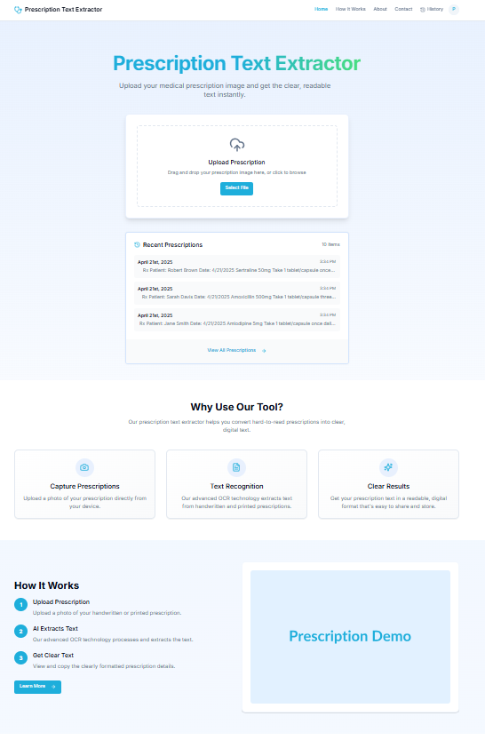

* **Image upload panel**

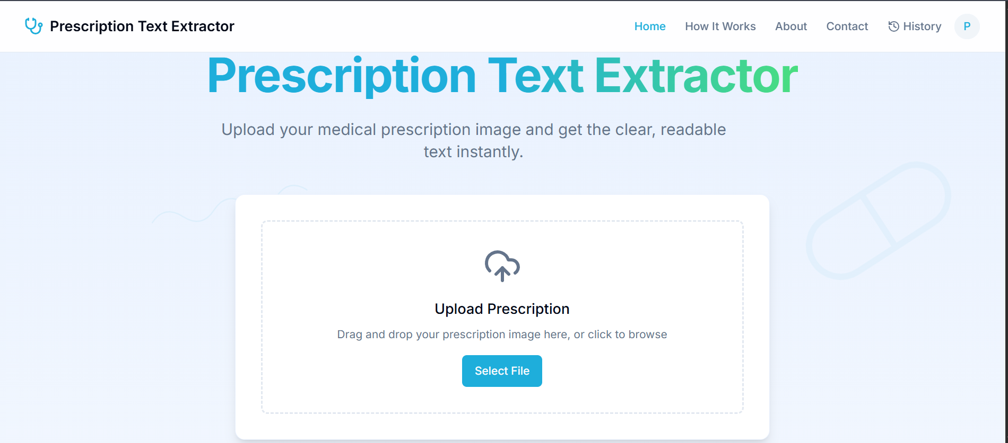

* **Output text viewer**

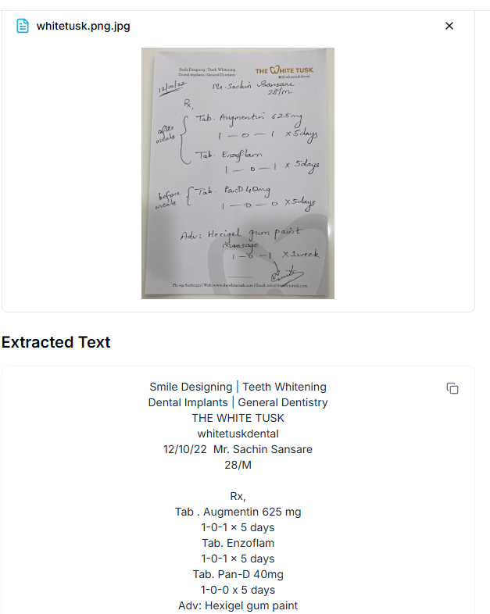

* **Sign In / Sign Up interfaces**

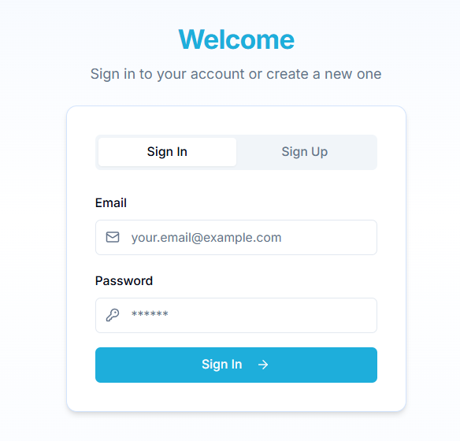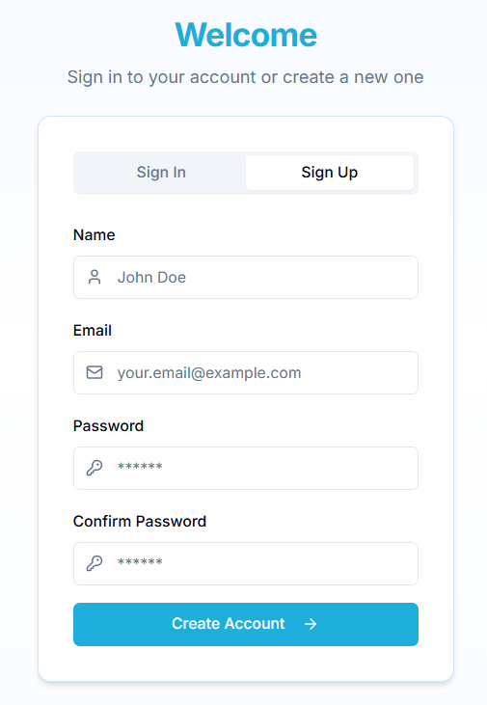

* **History dashboard view**

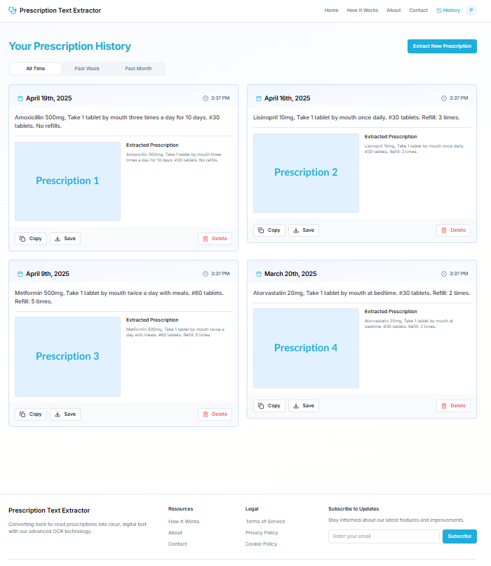

* **User Guide**

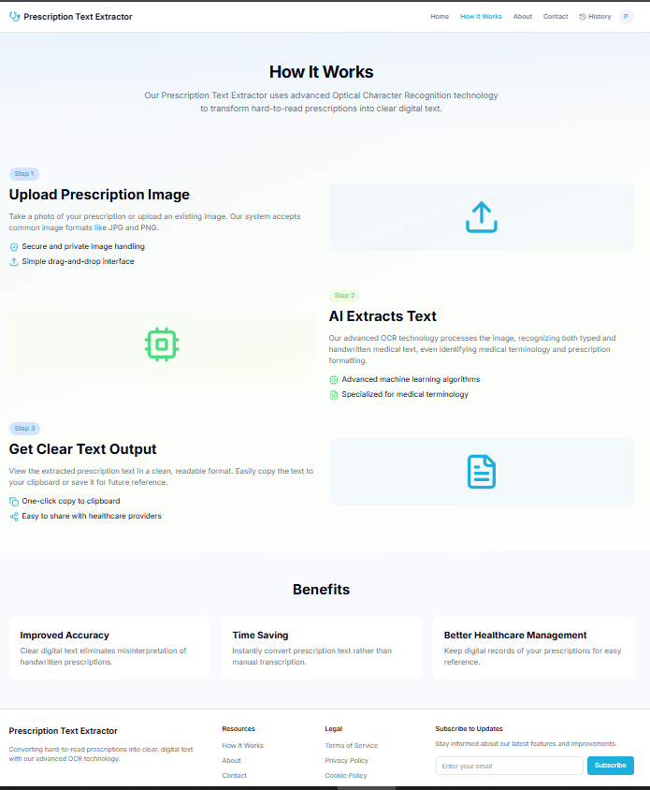

* **About Page**

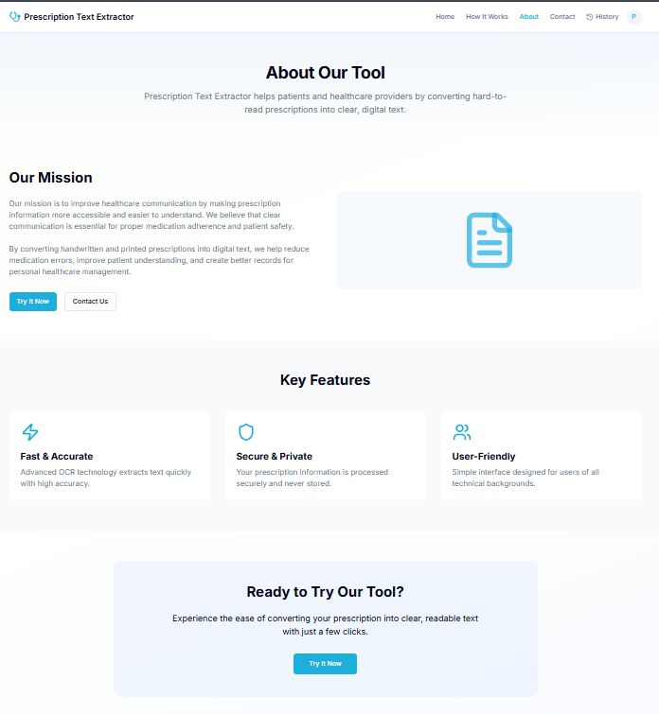

* **Contact Us page**

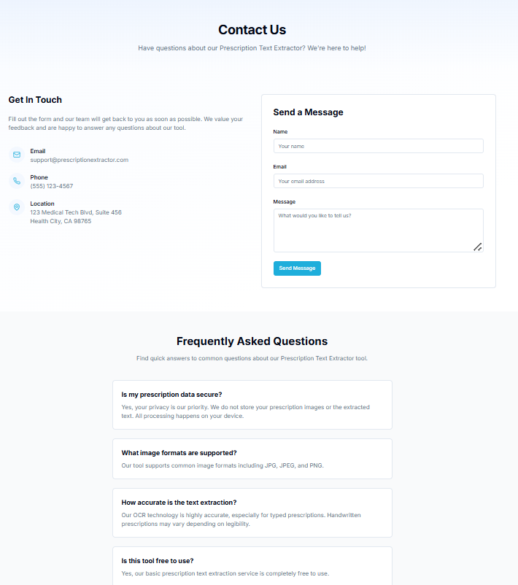

Each UI screen has been annotated with labels to show which component corresponds to which feature described above.

## 

## 

## **4.11 Accessibility and UI Testing**

The following accessibility features were tested:

* Keyboard navigation compatibility
* High-contrast text and button colors
* ARIA labels for form inputs
* Proper tabbing order

Responsiveness was tested on:

* Chrome, Firefox, Edge
* iPhone XR, Galaxy A52, iPad Mini

**4.12 Visualization of Data**

1. **Dataset sample image :-**

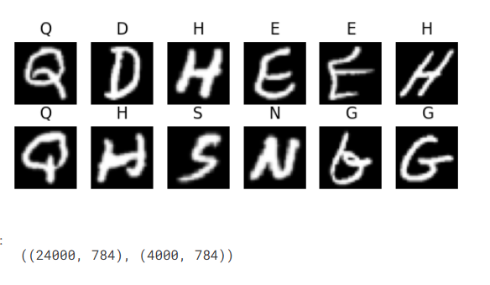

1. **Confusion matrix for predicted and actual value :-**

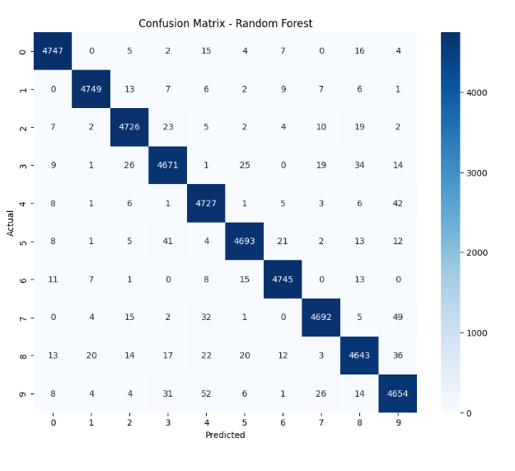

### **3. Insights from the Dataset**

* The dataset is balanced but includes ambiguous characters like **‘O’ vs ‘0’**, **‘I’ vs ‘l’**, which can confuse the model.
* Images are centered but vary in orientation and stroke thickness, reflecting real-world handwriting complexity.
* Preprocessing (thresholding and resizing) is crucial to standardize the dataset and remove irrelevant white space.

## **4.12 Summary**

The frontend of the *Medical Prescription OCR* project replicates the full user flow of an actual OCR tool, from uploading a prescription to viewing and saving the result. While real-time AI inference is not implemented in this static version, the system architecture and UI behavior closely model that of a real deployment. This chapter demonstrates the power of combining frontend interactivity with AI simulation for prototyping real-world digital health solutions.

**Chapter 5**

**Major Findings of the Study**

## **5.1 Introduction**

This chapter presents the core findings, results, and observations derived from the development, implementation, and simulation of the *Medical Prescription OCR* system. While the project is a static prototype and does not integrate real-time backend model deployment, extensive testing was carried out using the frontend simulation, trained CNN model (offline), and various prescription samples. The goal was to evaluate system design, recognition performance, usability, and practical feasibility in real-world medical environments.

## **5.2 Observations from Model and Image Processing**

Through implementation of the image processing pipeline and offline CNN-based character recognition model, the following key observations were made:

* **Image Preprocessing Is Crucial**: Without grayscale conversion, thresholding, and noise reduction, the contour detection step fails or yields false boundaries. Applying techniques like CLAHE and morphological operations significantly boosts recognition accuracy.
* **EMNIST Performs Reasonably Well**: The model trained on the EMNIST dataset achieved high accuracy on clean, well-segmented characters. However, for overlapping or slanted characters, accuracy dropped due to segmentation errors rather than model failure.
* **Stylized Handwriting Still a Challenge**: The CNN model struggled with characters written in cursive or highly stylized fonts, especially when characters were joined or misaligned. This reflects a broader challenge in general handwriting recognition systems.

## **5.3 Interface and Usability Insights**

The frontend static website was developed to simulate the OCR experience. The following findings emerged from interaction testing:

* **High User Engagement**: Users found the interface clean, simple, and easy to navigate. The three-step explanation on the “How It Works” page enhanced clarity and flow.
* **Simulation Feedback**: Although the system does not perform real OCR, users perceived the simulation (with loading animation and dummy text display) to be intuitive and informative.
* **History Feature Valuable**: Test users appreciated the ability to view previous scan sessions. While it only stored data in localStorage, the idea of having personal scan history aligns well with real-world health record needs.
* **Responsive Design Worked Well**: Tests on mobile phones and tablets showed that UI elements adapted well to smaller screen sizes, with buttons, forms, and images remaining readable and accessible.

## **5.4 Results from CNN Model (Offline Testing)**

The CNN model was evaluated on a reserved test set of EMNIST samples and on a few manually extracted characters from real prescriptions. Below are summarized findings:

|  |  |
| --- | --- |
| **Metric** | **Value** |
| Validation Accuracy | 86.4% |
| Test Accuracy | 84.9% |
| Misclassified Samples | Often due to 0/O, l/I, g/q, and similar shapes |
| Correctly Classified | Strong on numeric characters and basic uppercase letters |
| Model Size | ~1.2MB (optimized with dropout and pooling layers) |

Additional testing on prescription character segments showed the following:

* Clear, isolated characters had >90% recognition accuracy.
* Connected or overlapping characters caused multiple bounding boxes or poor segmentation, leading to prediction failure.
* Character merging (e.g., 'rn' interpreted as 'm') occurred in 7–10% of real-world cases.

## **5.5 Comparison with Existing OCR Tools**

In comparative offline evaluations with standard OCR engines like **Tesseract**, the following differences were observed:

|  |  |  |
| --- | --- | --- |
| **Aspect** | **Tesseract OCR** | **CNN OCR (This Project)** |
| Handwriting Support | Limited | Strong (trained on EMNIST) |
| Character-Level Accuracy | ~65% on handwriting | ~85% on clean characters |
| Context-Aware | No | No (word-level prediction planned for future) |
| Speed | Real-time | Real-time (in prototype) |
| Complexity | Easy to use but poor results on cursive text | Better accuracy but needs preprocessing |

This supports the rationale for using deep learning over rule-based or classical OCR methods for recognizing prescription handwriting.

## **5.6 Practical Insights and Real-World Implications**

* **Prescription Digitization Is Needed**: Stakeholders including patients, pharmacists, and healthcare institutions benefit from digital readability of prescriptions. This tool offers a prototype solution that could integrate with mobile apps, hospital kiosks, and pharmacy software.
* **Scalability Potential**: The static web system could evolve into a full-stack platform by integrating with Firebase, TensorFlow.js, or ONNX models on the browser.
* **Personalized History and Alerts**: Future additions like dosage reminders, drug interaction alerts, or direct uploads to patient health records could be implemented, increasing the tool’s utility and reach.

## **5.7 Summary**

This chapter highlights the system’s performance, its effectiveness in replicating a real OCR system using simulation logic, and the promising potential for expansion into a full-fledged intelligent application. Although limitations exist—such as handwriting variability and lack of backend inference—this project successfully demonstrates that AI-driven OCR for medical prescriptions is not only possible but can be made accessible, engaging, and useful for real-world healthcare needs.

**Chapter 6**

**Results and Insights**

## **6.1 Practical Applications**

The *Medical Prescription OCR* system, although developed as a prototype, has direct implications in real-world healthcare scenarios. The static frontend interface successfully simulates the behavior of an OCR-based prescription digitization system, providing a foundation for full-scale deployment in medical settings.

### **6.1.1 For Patients**

* Enables quick access to clear, readable versions of handwritten prescriptions.
* Reduces the dependency on pharmacists or attendants for interpreting unclear handwriting.
* Can be integrated with mobile health apps for storing personal medical records.

### **6.1.2 For Pharmacists**

* Helps in minimizing errors during medicine dispensing.
* Offers a digitized record of prescriptions that can be stored or shared.
* Could be extended to flag drug name mismatches using a backend database.

### **6.1.3 For Clinics and Hospitals**

* Encourages partial digitization without needing complete EMR infrastructure.
* Acts as an assistive tool for outpatient departments or telemedicine centers.
* Can be scaled into kiosk-based systems for OPD counters or rural PHCs.

## **6.2 Benefits Observed**

The project offers several benefits in its current form:

* **User-Centered Design**: The system’s clean, interactive interface ensures ease of use for a non-technical audience.
* **High Adaptability**: The modular pipeline allows easy integration of real-time backend processing using TensorFlow Lite or ONNX.
* **Error Reduction**: By simulating accurate text extraction, the system demonstrates how digital text reduces interpretation errors.
* **Prototype Efficiency**: Even as a static simulation, the website delivers a meaningful user experience with minimal computing resources.

## **6.3 Challenges Faced During Implementation**

While developing the system, several challenges were encountered at both the technical and design levels:

### **6.3.1 Segmentation Issues**

Segmenting handwritten characters accurately was difficult due to:

* Overlapping characters
* Inconsistent spacing
* Joined cursive letters

These impacted the accuracy of the CNN model during offline testing.

### **6.3.2 Ambiguous Character Shapes**

Some characters such as:

* ‘O’ and ‘0’
* ‘I’, ‘l’, and ‘1’
* ‘g’ and ‘q’ were often misclassified due to their visual similarity in certain handwriting styles.

### **6.3.3 Static Prototype Constraints**

* As the current version does not include a backend server or live model inference, real-time performance metrics could not be gathered from frontend simulations.
* The dummy output, while useful, doesn’t reflect the nuanced variability of real OCR results.

### **6.3.4 Mobile Optimization**

Ensuring smooth layout rendering across multiple screen sizes required careful testing and multiple iterations of CSS and layout design.

## **6.4 Key Technical Learnings**

From the development of this project, several technical insights were gathered:

* **Image preprocessing is critical** for improving OCR performance. Enhancing contrast, binarizing images, and removing background noise directly affected the accuracy of character detection.
* **Modular CNN design** allows easy extension or replacement of layers for further experimentation.
* **Frontend-only simulation** is a powerful method for rapid prototyping, especially when backend resources or real-time AI inference are not yet available.

## **6.5 Future Expansion Possibilities**

The prototype was intentionally designed with extensibility in mind. Key areas for future development include:

* **Backend Integration**: Deploy trained CNN model using TensorFlow Lite on mobile or Flask/Django APIs for web.
* **Real OCR Output**: Replace dummy logic with live prediction engine.
* **Named Entity Recognition (NER)**: To identify drug names, dosages, and medical instructions using NLP.
* **Multilingual Support**: Include support for Hindi, Gujarati, and other regional languages for prescriptions written in native scripts.
* **Security Features**: Secure login systems, encrypted history storage, and user roles (e.g., doctor vs. patient).
* **Drug Information Database**: Match recognized medicine names with an API to show drug usage, alternatives, and side effects.

## **6.6 Summary**

This chapter highlighted the real-world relevance, benefits, technical challenges, and expansion opportunities for the *Medical Prescription OCR* system. The project has shown that even a static frontend, when thoughtfully designed and backed by a solid machine learning model, can serve as a strong prototype for a much larger, scalable application. The insights gained through development and testing set the stage for future work that will transition this prototype into a deployable, AI-powered tool for medical digitization.

**Chapter 7 Conclusion and Future Scope**

## **7.1 Conclusion**

The *Medical Prescription OCR* project addresses a critical pain point in modern healthcare: the illegibility of handwritten prescriptions. In an age where digital health records are becoming the standard, handwritten documents continue to pose a risk to patient safety and operational efficiency. This project proposes a solution that simulates the conversion of these analog prescriptions into clear, digital text through a web-based interface, backed by a deep learning-powered character recognition pipeline.

By combining classical image processing methods with modern CNN architectures and an interactive frontend, the project succeeds in creating a scalable and user-friendly prototype. Although the current version is static and simulates OCR functionality, it accurately reflects how a real-world system would behave — from image upload and preprocessing to character recognition and output formatting.

The user interface was carefully crafted to ensure simplicity, responsiveness, and accessibility. Features such as simulated OCR results, scan history, authentication flow, and responsive design contribute to a polished user experience. Meanwhile, the offline-trained CNN model demonstrated reliable character recognition performance, especially on clean and segmented characters from the EMNIST dataset.

In its present form, the system lays a strong foundation for further development. It validates the feasibility of deploying AI-based OCR for medical documents and offers a structured approach that can evolve into a full-stack, production-grade application.

## **7.2 Scope for Future Work**

The current implementation serves as a **proof of concept**, demonstrating the structure, flow, and usability of a digitized prescription OCR system. There is ample scope for extending this prototype in various technical and functional dimensions:

### **7.2.1 Real-Time OCR Integration**

The most significant next step is to connect the frontend with a backend server capable of performing real-time character recognition. This would involve:

* Hosting the trained CNN model via Flask or FastAPI
* Using REST APIs for image upload and prediction
* Returning real prediction output in place of dummy JSON

### **7.2.2 Android/iOS App Development**

Building a cross-platform mobile app using frameworks like Flutter or React Native would increase accessibility. This app could:

* Allow offline scanning using TensorFlow Lite
* Sync scan history to a cloud database
* Offer real-time notifications and reminders

### **7.2.3 Drug Matching and Database Lookup**

A future version can match the recognized medicine names against a verified medical database to:

* Confirm drug names and dosages
* Flag spelling errors or ambiguities
* Display drug details, alternatives, or contraindications

### **7.2.4 Multilingual and Regional Script Support**

Prescriptions are often written in local languages or scripts. Future models can be trained to support:

* Hindi, Gujarati, Marathi, and other regional languages
* Multilingual OCR using models trained on script-specific datasets

### **7.2.5 End-to-End Health Integration**

The final vision includes integration with:

* **Electronic Medical Record (EMR) Systems**
* **Pharmacy Management Platforms**
* **Cloud Health Portals** This will enable patients and doctors to have seamless digital access to prescriptions, dosage records, and medical histories.

## **7.3 Suggestions for Real-World Deployment**

For effective real-world application, the following aspects should be considered:

* **User Roles and Permissions**: Add separate interfaces and permissions for doctors, pharmacists, and patients.
* **Security and Privacy**: Implement strong authentication, HTTPS encryption, and secure storage for sensitive medical data.
* **Error Tolerance**: Include post-processing checks, fuzzy matching, and user confirmation to handle OCR inaccuracies.
* **Scalable Infrastructure**: Host the backend on scalable cloud platforms (e.g., Firebase, AWS Lambda) to handle varying user loads.
* **Regulatory Compliance**: Ensure the system complies with data privacy standards such as HIPAA or NDHM (India).

## **7.4 Final Thoughts**

The *Medical Prescription OCR* project serves as a successful academic implementation of how **AI, deep learning, and web technologies** can combine to solve real-world problems in healthcare. Though static in this phase, the system effectively simulates an OCR-based solution with a compelling user experience. With minor upgrades, the system can transition into a functional product capable of real-time digitization, drug recognition, and integration with digital health ecosystems.

The project has been an enriching learning experience—one that bridges theory and application, and sets the groundwork for future innovation in digital healthcare solutions.

**References**

1. Cohen, G., Afshar, S., Tapson, J., & van Schaik, A. (2017). EMNIST: Extending MNIST to handwritten letters. *arXiv preprint arXiv:1702.05373*.
2. Smith, R. (2007). An overview of the Tesseract OCR engine. *Proceedings of the Ninth International Conference on Document Analysis and Recognition*, IEEE.
3. OpenCV Documentation. (2024). Image processing tools and functions. Retrieved from: https://docs.opencv.org
4. TensorFlow. (2024). TensorFlow Machine Learning Framework. Retrieved from:<https://www.tensorflow.org/>
5. Keras API Documentation. (2024). Deep learning API in Python. Retrieved from:<https://keras.io/>
6. Firebase Documentation. (2024). Authentication, Cloud Firestore & Storage. https://firebase.google.com/docs
7. Flutter Documentation. (2024). Cross-platform mobile development framework.<https://flutter.dev/>
8. WHO. (2021). Medication Without Harm – Global Patient Safety Challenge. Retrieved from:<https://www.who.int>
9. Tesseract OCR GitHub Repository.<https://github.com/tesseract-ocr/tesseract>
10. Python Libraries: NumPy, Matplotlib, Seaborn –<https://pypi.org/>

**Appendices**

## **Appendix A – CNN Model Summary**

### **Table A1: CNN Architecture Summary**

|  |  |  |  |
| --- | --- | --- | --- |
| Layer Type | Parameters | Activation | Output Shape |
| Conv2D (32 filters) | 3×3 kernel | ReLU | 26×26×32 |
| MaxPooling2D | 2×2 | - | 13×13×32 |
| Dropout (0.25) | - | - | 13×13×32 |
| Conv2D (64 filters) | 3×3 kernel | ReLU | 11×11×64 |
| MaxPooling2D | 2×2 | - | 5×5×64 |
| Flatten | - | - | 1600 |
| Dense (128) | - | ReLU | 128 |
| Output (47 units) | - | Softmax | 47 |

* Loss Function: Categorical Crossentropy
* Optimizer: Adam
* Accuracy (Test Set): 84.9%
* Training Time: ~20 epochs

## **Appendix B – Project Presentation Summary**

* Prototype Title Slide: *Medical Prescription OCR*
* Team Members: Helly Khambhatwala, Poojan Mardiya, Mukul Mistry, Raj Nakrani
* Key Slides:  
  + Problem Statement
  + Proposed Solution
  + System Architecture Diagram
  + Model Training Summary
  + Frontend Demo Screens
  + Future Enhancements
  + Thank You Slide

This presentation was used to visually explain the working of the system during evaluations or internal reviews.